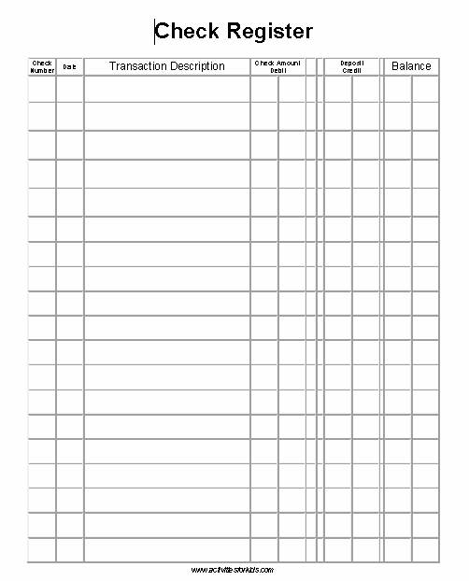

*Whether you have a check register in your purse or wallet that looks similar to this, or an app on your phone that looks similar to this, it’s a smart idea to keep track YOURSELF (independent of the bank or credit union) of all your deposits and debits. The bank, after all, is in the business of making money, and they will gladly take yours if you overdraft your account. It is not unheard of for them to make mistakes, or for one of their machines to “malfunction” as well. You must also consider money you’ve taken out that hasn’t “cleared” yet. For all these reasons, it’s a good idea to keep a check register of all your transactions.
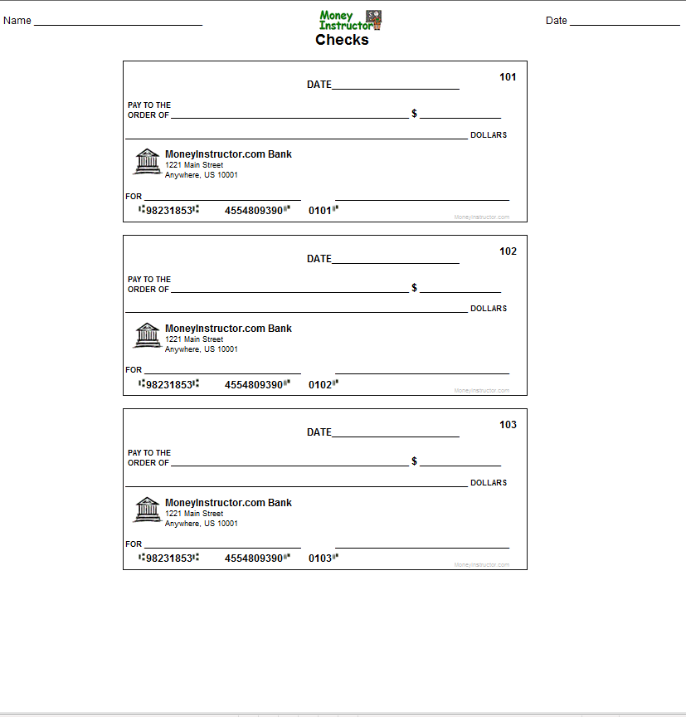
*I know it seems weird to fill out a check, but there are still some places that will not accept the “tap of your phone” or even cash. Some establishments want to hold a check for large purchases in advance. Some may want the relative of the check…something called a “money order” (very much like a check, but it is sold at banks, and protected by them)
So it’s a good idea to know your way around a check, and what things are needed on it. You would be surprised the number of times a college student has to have a check for tuition intent related things, and stands at the registrar’s office looking confused. (BTW, if you get a check from someone, to cash it, you need to ENDORSE the back. You write your name on the back where space is provided)
Do not write below this line
Back of check: Where you would ENDORSE if a person wrote a check to you and you wanted to cash it.

