**C:\Program Files (x86)\Microsoft Office\MEDIA\CAGCAT10\j0185604.wmfLet’s Go House Hunting!**

You have already calculated approximately what you can afford to spend on housing each month, based on your income. A house is one of the biggest purchases you will make in your lifetime.

*Based on what you calculated as the* ***Approximate Amount You Plan to Spend on a home***, *find a house that you can afford to purchase. Do these things:*

1. **Strategy:** You are figuring an UNKNOWN. You FIRST find out the TOTAL cost of the house, and from that, the monthly payment. (That unknown is how much total house you can buy if you can afford only so much per month.) (That 35% of your monthly income) ***To find out how much house you can buy (Full purchase price) for your monthly income, use the loan payment calculator (***([http://www.bankrate.com/calculators/mortgages/mortgage-calculator.aspx](http://www.bankrate.com/calculators/mortgages/mortgage-calculator.aspx%20) ) ***Start with a $100,000 house, and go up or down according to the amount per month it figures. Then you’ll have a ballpark figure. Fill out the form, with the total you want to see if you can afford, then a $20,000 down payment if applicable, 30 yr mortgage, and 5% interest rate. Then hit “Calculate”. Match the resulting monthly payment to your 35% number, and see if they match. If they are higher or lower, adjust the “total cost of house” number in the 1st box.***

2. Find an Indiana house that you like and that is in your budget. (From your “ballpark” number of what you can afford per month. Use these websites.

* <http://www.trulia.com>

Feel the pain-Navigate the site just like a real buyer. Adapt their interest rates, etc. to yours below (You need a 5% interest rate, and a 30 year loan) Sort out the info you need from the ads.

* <http://www.realtor.com>
* <http://www.realestate.com>
* <http://www.homeseekers.com>

2. Once you find a home you like, go back to the Loan Payment Calculator ([http://www.bankrate.com/calculators/mortgages/mortgage-calculator.aspx](http://www.bankrate.com/calculators/mortgages/mortgage-calculator.aspx%20) )  
to double check that you can afford the monthly payment, and to figure the EXACT amount per month you will pay on that exact house. Make sure that the monthly payment falls within your planned spending amount. For example, if you calculated that you could spend $800.00 per month on your house payment, then your monthly payment should be less than or equal to $800.00.

Reminder: **In the Loan Payment Calculator**:

*Put the total price of the house in the “Principal” box

*Use 5.0 as the “Interest Rate”

*Type “30” in the “Number of Years” box3.

*If you have a down payment, subtract it at the beginning or if a box for a down payment is there, put the amount from your Aunt in there.

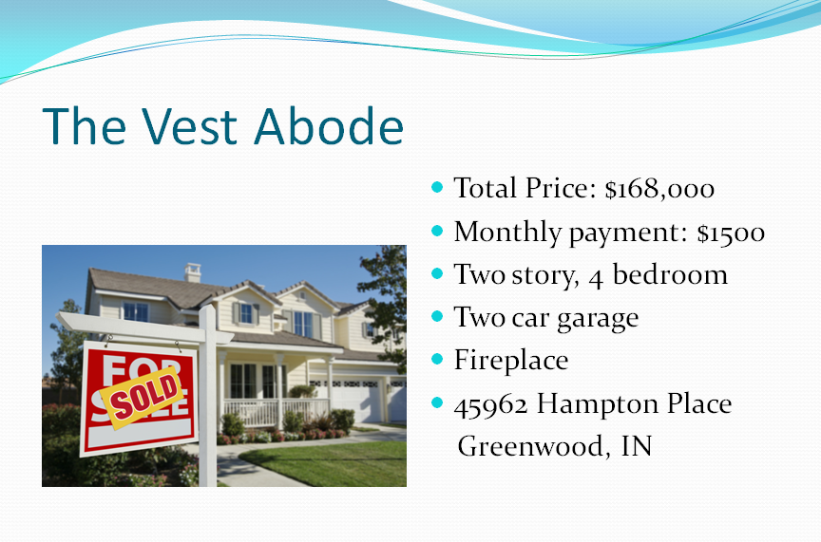Once you have your house, save a picture of it, and make a PPT slide that includes a title, a picture of the house, the price of the house, the monthly payment, its address, and a description of its main features (yours should be a 5 sentence paragraph). Figure out if you have

Electric

Gas

Water

Sewage

Trash

*Put the approximate amount you would pay for these per month, using the 5%, 5%, 2% from your Slide 10 planning sheet. Put this information at the bottom of your slide.

Alternate Mortgage Loan Payment Calculator: http://www.mlcalc.com/