Let’s Buy a Ride!
You have already calculated approximately what you can afford to spend on a vehicle each month, based on your income. A car is also one of the biggest purchases you will make in your lifetime. Oh, and SURPRISE! Your rich aunt Bertha is giving you $1000.00 to use as a down payment on your car.
Based on what you calculated as the Approximate Amount You Plan to Spend on a car, find a new or used vehicle that you can afford to purchase. Do these things:

1. Search for a car at the sites below. Make sure that car is affordable within your budget. Since you live in Greenwood, I would use 46142 as your zip code if needed. Navigate around the websites just like a real buyer, and don’t be led astray!
- http://www.cars.com
- http://autoweb.com
- http://carpoint.msn.com
- http://www.autotrader.com

2. Once you find a car that you like, use this Loan Payment Calculator http://www.bankrate.com/calculators/auto/simple-loan-payment-calculator.aspx to see if you can afford it. You must make sure that the monthly payment falls within your planned spending amount. For example, if I calculated that I could spend $250 per month on my car payment, then my monthly payment should be $250 or less than $250.
In the Loan Calculator:
*Figure the total price of the loan by subtracting your Aunt Bertha’s gift of $1000 from the total cost.
*Put that total cost of the car in the “Principal” box
*Use 7.0 as the “Interest Rate”
*In the “Number of Years” box, put a number from 3 to 5 (that’s the typical number of years it will take you to pay off the loan)
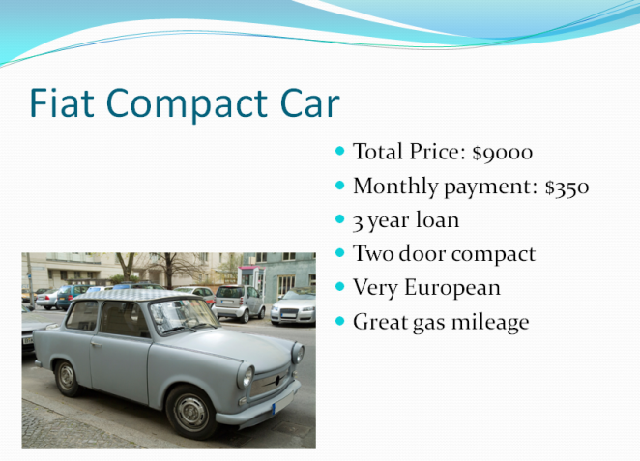
3. When you find “that perfect car” that fits your budget, save a picture of it to put on a PPT slide. Other items to put on the slide are:
A title, Total Price of the car, monthly payment, length of the loan, and some of its features. *Alternate Loan payment Calculator: http://autos.yahoo.com/car-finance/monthly-loan-calculator.html

